Naming and Drawing Hydrocarbon Structures

Provide the IUPAC names for each of the following compounds. Indicate whether the hydrocarbon is either an aliphatic, cyclic, or aromatic hydrocarbon. If the hydrocarbon is aliphatic, or cyclic, indicate whether the hydrocarbon is an alkane, alkene, or alkyne. (3 marks each)

- 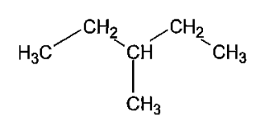 | - 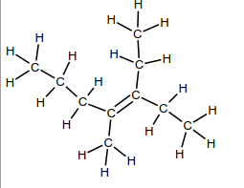
- 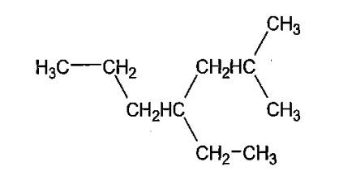 | - 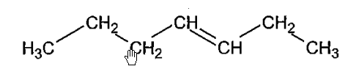
- 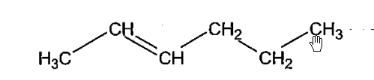 | - 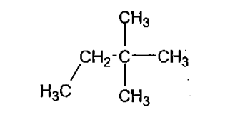
- 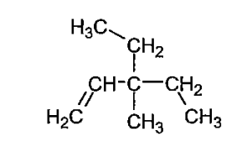 | - 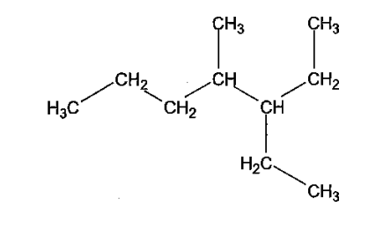
- 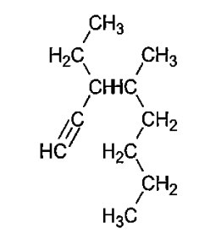 | - 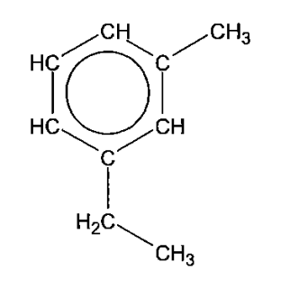
- 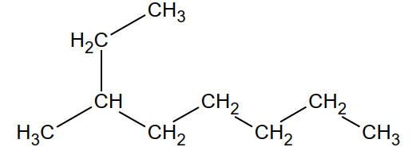 | - 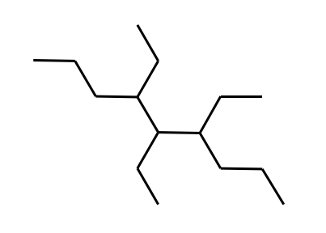
- 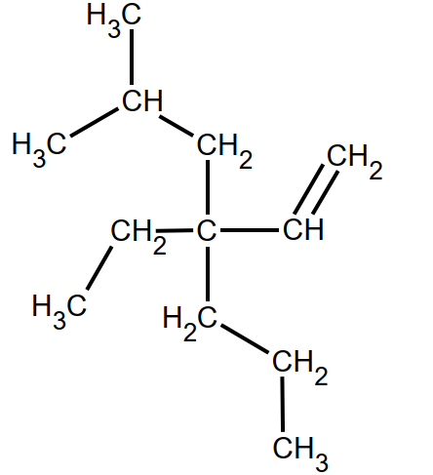 | - 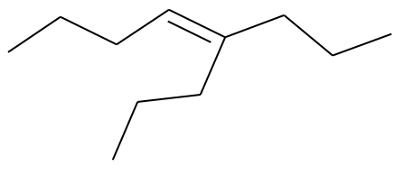
- 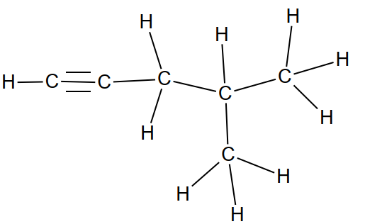 | - 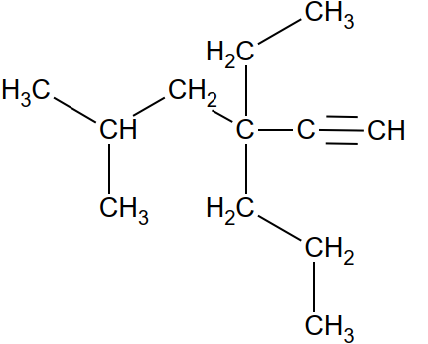

- 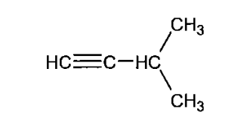 | - 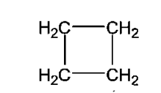
- 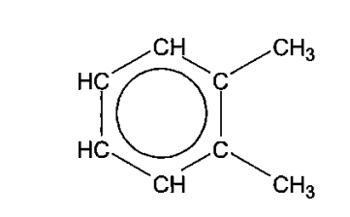 | - 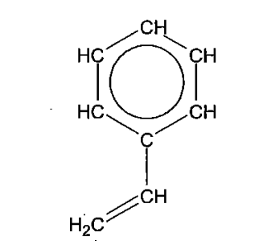
- 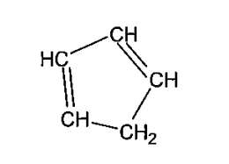 | - 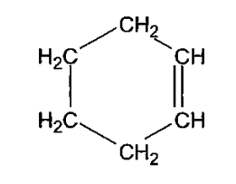
- 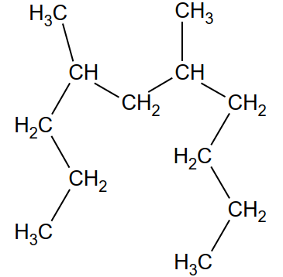 | - 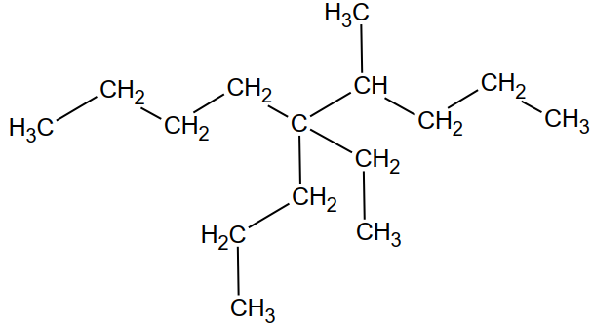
- 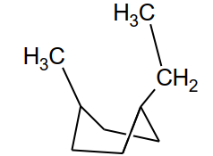 | - 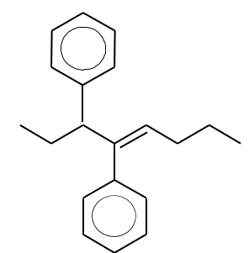

Draw condensed structural diagrams for the following compounds: (2 marks each)

- 3-methylhexane | - Methylpropene
- 2,3-dimethylhexane | - 3,4-dimethylhept-1-yne
- 3-methyl-4-propylnonane | - Cyclopentane
- 3,4-diethyl-3-methylheptane | - Methylcyclobutane
- Pent-1,3-diene | - 4-ethyl-2-methylcyclohexene
- 4-ethyl-4,6,6-trimethylnonane | - 2,2,3,3-tetramethyl-4-propylheptane
- 3-ethyl-4-methyl-3-propylhept-1-ene | - 2,2,5,5,6,6-hexamethylhept-3-yne

- 1,2-dipropylbenzene | - 1,3-diethylbenzene
- 1,3,5-trimethylbenzene | - 1-methyl-4-propylbenzene

The following compounds names may or may not be correct. If they are correct, please write the condensed structural formula for the compound. If they are incorrect, please give the condensed structural formula and the proper IUPAC name. (3 each)

- 3,4-dimethylpentane | - 1,2,4-methyl-3-ethylcyclohexane
- 3-methyl-4-propylpentane | - 1,1-dimethyl-2,2-diethylbutane
- 1,2-dimethyl-4,4-diethyloctane | - 1,3-dimethylpropane

The boiling point of propane is -44.5°C and that of propene is -47.8°C. Is this consistent with the nature of the intermolecular forces present in both these hydrocarbons? Explain. (3 marks)

